NAVODAYA VIDYALAYA SAMITI

PROSPECTUS FOR JAWAHAR NAVODAYA VIDYALAYA SELECTION TEST- 2014

1. NAVODAYA VIDYALAYA SCHEME
1.1 Introduction
In accordance with the National Policy of Education (1986) Government of India started Jawahar Navodaya Vidyalayas (JNVs). Presently the JNVs are spread in 27 States and 7 Union Territories. These are co-educational residential schools fully financed and administered by Government of India through an autonomous organization, Navodaya Vidyalaya Samiti. Admissions in JNVs are made through the JAWAHAR NAVODAYA VIDYALAYA SELECTION TEST (JNVST) at Class VI. The medium of instruction in JNVs is the mother tongue or regional language up to Class VIII and English thereafter for Maths and Science and Hindi for Social Science. Students of the JNVs appear for X and XII class examinations of the Central Board of Secondary Education. While education in the schools is free including boarding, lodging, uniforms and textbooks, a nominal fee of Rs.200/- per month will have to be paid by the children from IX to XII class. However, children belonging to SC/ST, Girls and Physically Handicapped and from the families whose income is below poverty line are exempted from payment of fees.

1.2 Objective of the Scheme
- To provide good quality modern education including a strong component of culture, inculcation of values, awareness of the environment, adventure activities and physical education to the talented children predominantly from rural areas.
- To ensure that students attain a reasonable level of competency in three languages.
- To promote national integration through migration of students from Hindi to non-Hindi speaking State and vice-versa.
- To serve in each district as focal point for improvement of quality of school education in general through sharing of experiences and facilities.

1.3 State-wise Distribution of Jawahar Navodaya Vidyalayas
According to the Navodaya Vidyalaya Scheme, one Jawahar Navodaya Vidyalaya is to be set up in each District in a phased manner. At present, there are 595
(576+19**) Vidyalayas are sanctioned in 27 States and 7 Union Territories. Out of which 583(567+16) are functioning. The State-wise distribution of JNVs is as under:

Andhra Pradesh | 22+2 | Haryana | 20 | Nagaland | 11
Assam | 27+1 | Himachal Pradesh | 12 | Orissa | 30+1
Arunachal Pradesh | 16 | Jammu & Kashmir | 17+1 | Punjab | 20+1
Andaman & Nicobar Islands | 02 | Jharkhand | 22+2 | Pondicherry | 04
Bihar | 38+1 | Karnataka | 27+1 | Rajasthan | 32+2
Chandigarh | 01 | Kerala | 14 | Sikkim | 04
Chattisgarh | 16+1 | Lakshadweep | 01 | Tripura | 04
Delhi | 02 | Madhya Pradesh | 48+2 | Uttar Pradesh | 70
Daman & Diu | 02 | Maharashtra | 32+1 | Uttaranchal | 13
Dadra & Nagar Haveli | 01 | Manipur | 09 | West Bengal | 17+1
Goa | 02 | Meghalaya | 07+1 | Total | 576+19**  =595
Gujarat | 25+1 | Mizoram | 08
** Additional JNVs sanctioned for the Districts having large concentration of SC/ST population.

A maximum of eighty students are admitted in Class VI in each Vidyalaya, through a Selection Test subject to availability of suitable candidates. The Samiti reserves the right to reduce the seats to forty or to withhold result and/or withhold admission and/or conduct of JNVST in case adequate accommodation is not available.

1.4 Jawahar Navodaya Vidyalaya Selection Test - 2014

JNV Selection Test for admission to Class-VI in JNVs for the academic session 2014-15 will be held as per following schedule. The last date for submission of Application Form in BEO’s Office is 31st October 2013.

    - On Saturday, the_08th February, 2014 at 11.30 A.M. in the State of Andhra Pradesh, Assam, Bihar, West Bengal (except Darjeelin0g) Chhattisgarh, Goa, Gujarat, Haryana, Himachal Pradesh (except Chamba, Kinnaur, Mandi, Sirmour, Kullu, Lahaul & Spiti and Shimla Districts), Jharkhand, Kerala, Karnataka, Madhya Pradesh, Maharashtra, Manipur, Orissa, Punjab, Rajasthan, Tripura, Uttar Pradesh, Uttaranchal, Delhi, Arunachal Pradesh (except Tawang District), Union Territories of Andaman & Nicobar Islands, Chandigarh, Dadar & Nagar Haveli, Daman & Diu, Lakshadweep and Pondicherry .
    - On Saturday 12th April, 2014 at 11.30 A.M. in the States of Meghalaya, Mizoram, Nagaland, Sikkim ,Jammu and Kashmir (except Leh & Kargil) and in the District of Tawang of Arunachal Pradesh, in the Districts of Chamba, Sirmour, Kullu, Kinnaur, Mandi, Shimla of Himachal Pradesh, in the District of Darjeeling of West Bengal.
iii. On Saturday 07th June, 2014 at 11.30 A.M. in the Districts of Leh, Kargil of J&K State and in the District of Lahaul & Spiti of Himachal Pradesh State.

2. HOW TO APPLY FOR JNV SELECTION TEST
2.1 How to get an Application Form?
Application forms for admission may be made on the prescribed Application Form (attached with the prospectus) available free of cost from:
- Block Education Officer (BEO)
- District Education Officer (DEO)
- Headmaster of any Govt. / Govt. aided / Recognized Accredited Institute / Centre of Sarva Shiksha Abhiyan / NIOS where he/she is studying.
- Principal, Jawahar Navodaya Vidyalaya.

In case of non-availability of JNVST prescribed Application Form from the above, you may copy the format of Application Form on plain paper (preferably 21cm x 30cm) from our website at the address http://www.navodaya.nic.in or the newspaper advertisement and apply on it.

  - How to submit an Application Form?

Duly filled in application form must reach the Block Education Officer latest by 31st October 2013. It shall be signed by the Head of the recognized school/Special Education Scheme (Sarva Shiksha Abhiyan) where the child is studying in Class-V, on or before 31st October 2013 (Candidates are advised to get the acknowledgement from the BEO at the time of submission of Application Form).

2.3 Issue of Admit Cards

Admit Cards, duly prepared by the Principal, Jawahar Navodaya Vidyalaya will be issued to the candidates through the office of the Block Education Officer. Candidates, who do not receive their Admit cards one week before the JNVST should immediately contact to Principal, JNV/BEO/DEO for the same.

2.4 Result of the Selection Test

The result of JNV Selection Test 2014 is expected to be announced by end of May of the year of admission. The result will be displayed in the offices of the concerned (i) Jawahar Navodaya Vidyalaya (ii) District Education Officer (iii) District Magistrate (iv) Deputy Commissioner, Navodaya Vidyalaya Samiti of the Region. The Principal, Jawahar Navodaya Vidyalaya concerned, will also inform the selected candidates through registered post. The result will also be displayed on website of the Navodaya Vidyalaya Samiti at the address http://www.navodaya.nic.in

- SELECTION AND ADMISSION

3.a) Selection in the test will not vest any right on the candidates to secure admission into the JNV. At the time of seeking actual admission, each selected candidate will have to produce all relevant certificates, as prescribed by the Navodaya Vidyalaya Samiti. Until admission, the selection is provisional.
3.b) In case of any dispute, the decision of Navodaya Vidyalaya Samiti shall be final and binding on the candidates.
3.c) Marks obtained by candidates (both selected and unselected) in the test are not communicated.
3.d) There is no provision for re-evaluation of the answer scripts. Since the result is processed through computer and sufficient care is taken to ensure accuracy through various checks in processing the result, no request for re-totaling of marks will be entertained.
3.e) It may also be noted by the candidates and their parents/guardians that under the scheme of JNVs, students of a JNV located in Hindi speaking State may have to be migrated to another JNV in Non-Hindi Speaking State and vice-versa for one academic year when the students are promoted to Class IX. In case of refusal from the students selected for migration, continuation of such students in JNV will not be allowed.
3.f) The candidates and their parents/guardians may note that the children selected on the basis of the Test will be admitted only in the JNV located in the district from where they are appearing at the JNVST. Under no circumstances, the selected candidate will be given admission to any other JNV. No request for shifting of students on account of medium of instruction in the JNV concerned, shifting of parents/guardians to other district(s) State(s) etc. will be entertained.
3.g) Candidates belonging to the Scheduled Castes (SCs) and Scheduled Tribes (STs) will have to produce a certificate of the Caste/Tribe at the time of seeking admission, if selected. Such certificate should be procured from the competent authority before 15th July, of the year of seeking admission so that it may be submitted to the Principal of concerned JNV at the time of admission.
3.h) Candidates belonging to the disabled category (Orthopedically Handicapped, Hearing Impaired and Visually Handicapped) if selected will have to produce a medical certificate signed by Chief Medical Officer of the District concerned at the time of admission.
3.i) Candidates belonging to the disabled category (Orthopedically Handicapped, Hearing Impaired and Visually Handicapped) can seek admission in the district in which they are studying in Class V on regular basis at the time of applying for JNVST or their native district where his/her parents are residing.

4. WHO IS ELIGIBLE

FOR ALL CANDIDATES:

4.a) Only the candidates from the district concerned where the Jawahar Navodaya Vidyalaya has been opened are eligible to apply for admission. However, the district where JNV is opened and is bifurcated at a later date, the old boundaries of the district are considered for the purpose of eligibility for admission into JNVST, in case a new Vidyalaya has not started in newly bifurcated district as yet.
4.b) A candidate seeking admission must not have been born before 01-05-2001 and after 30-04-2005. This will apply to candidates of all categories, including those who belong to the Scheduled Castes (SCs) and Scheduled Tribes (STs). In case of doubt of overage candidate seeking admission, they may be referred to the Medical Board for confirmation of the age. The decision of the Medical Board will be final.
4.c) A candidate appearing for the selection test must be studying in Class-V for the whole of the academic session 2013-14 in a Government/Government aided or other recognized schools or schools under schemes of “Sarva Shiksha Abhiyan” or ‘B’ certificate competency course of National Institute of Open Schooling in the same district where he/she is seeking admission. A school will be deemed recognized if it is declared so by the Government or by any other agency authorized on behalf of Government. The Schools under Sarva Shiksha Abhiyan are to be sponsored by Govt. or Govt. authorized agencies. Schools where students have obtained ‘B’ certificate under National Institute of Open Schooling should have accreditation of NIOS. A candidate must successfully complete Class-V in the session 2013-14. Actual admission in Class-VI for the session 2014-15 will be subject to this condition.
4.d) A Candidate claiming admission under rural quota must have studied and passed classes III, IV and V from a Govt. / Govt. aided / recognized school spending one full academic session each year in a school located in rural area.
4.e) Candidates who will be passing Class-V from schemes of “Sarva Shiksha Abhiyan” or ‘B’ certificate competency course of National Institute of Open Schooling on or before 30th September, 2014 are also eligible to write admission test provided they are in the prescribed age group. The forms of such candidates will be verified by DEO/DIOS. The rural status of a child from Accredited Centres/Institute of Sarva Shiksha Abiyan/National Institute of Open Schooling will be decided on the basis of a certificate to be issued by Tehsildar/District Magistrate of the District indicating that the child has been residing in rural areas for the last three years. Students studying under the above scheme from urban and notified areas are not eligible for obtaining seat in rural quota.
4.f) A Candidate who has not been promoted and admitted to Class-V before 30th September, 2013 is not eligible to apply.
4.g) No candidate is eligible to appear in the selection test second time, under any circumstances.
5. The parents of the children who qualify the Selection Test will have to submit following at the time of admission:

- Affidavit/Residence Certificate in prescribed Performa in addition to other documents demanded by the concerned Vidyalaya.
- For candidates seeking admission under rural quota, the parents will also have to submit an affidavit to the effect that the child is studying in an Institute located in a notified rural area and that they are residing in a notified rural area.

FOR RURAL CANDIDATES

A) At least 75% of the seats in a district will be filled by candidates selected from rural areas and remaining seats will be filled from the urban areas of the district.
B) A candidate seeking admission under the rural quota must have studied in Classes-III, IV and V completing full academic session from the recognized school(s) located in rural areas.
C) Candidates studying under the schemes of Sarva Shiksha Abhiyan and National Institute of Open Schooling should produce their rural status certificate issued by District Magistrate/ Tehsildar/Block Development Officer.
FOR URBAN CANDIDATES

A Candidate who has studied in a school located in an urban area even for a single day of session in Class-III, IV and V will be considered as an urban candidate. Urban areas are those which are so defined in 2001 census or through a subsequent Government Notification. All other areas will be considered as rural.

RESERVATION OF SEATS

a) | At least 75% of the seats in a district are filled by candidates selected from rural areas and remaining seats are filled from urban areas of the district.
b) | Reservation of seats in favour of children belonging to Scheduled Castes and Scheduled Tribes is provided in proportion to their population in the concerned district provided that no district, such reservation will be less than the national average (15% for SC and 7.5% for ST) but subject to maximum of 50% for both the categories (SC & ST) taken together. These reservations are interchangeable and over and above the candidates selected under open merit.
c) | One third of the total seats are filled up by girls.
d) | There is a provision for reservation of 3% seats for ** disabled children (i.e. Orthopedically Handicapped, Hearing Impaired and Visually Handicapped).

** “Blindness” refers to a condition where a person suffers from any of the following conditions namely:-
- Total absence of sight; or
- Visual acuity not exceeding 6/60 or 20/200 (snellen) in the better eye with correcting lenses; or
- Limitation of the field of vision subtending an angle of 20 degree or worse.

** “Hearing Impairment” means loss of sixty decibels or more in the better ear in the conversational range of frequencies.
** “Locomotor disability” means disability of the bones joints or muscles leading to substantial restriction of the movement of the limbs or any form of cerebral palsy.
** “Person with disability” means a person suffering from not less than forty percent of any disability as certified by a medical authority.

ABOUT THE SELECTION TEST

1. Centre for Examination
Each candidate shall appear for the selection test at the examination centre allotted to him/her as indicated on the Admit Card. No candidate is permitted to appear from any other centre. No request for change of centre will be entertained. No candidate can appear in the selection test without the proper Admit Card. The competent authority for issuing the Admit Card is Principal, JNV.

2. Language of the Examination

The language/medium of the examination for the candidate will be the medium through which the candidate is studying in Class-V.

A candidate will be given a test booklet in the language he/she has mentioned in the application form and admit card. It must be ensured that Same Medium of Examination/Language is written in the Application Form (Col.10) and Admit Card (Col.1). The test booklet is available in the following languages:

1. Assamese 2. Bengali 3. Bodo
4. English 5. Garo 6. Gujarati
7. Hindi 8. Kannada 9. Khasi
10. Malayalam 11. Manipuri 12. Marathi
13. Mizo 14. Oriya 15. Punjabi
16. Sindhi (Arabic) 17. Sindhi (Devnagri) 18. Tamil
19. Telugu 20. Urdu 21. Nepali

3. Composition of the Test

The selection test will be of two-hour duration and will have 3 sections with only objective type questions. There are 100 questions in all of 100 marks. Each question carries one mark:

Type of Test | Number of Questions | Marks | Duration
Mental ability Test | 50 | 50 | 60 Minutes
Arithmetic Test | 25 | 25 | 30 Minutes
Language Test | 25 | 25 | 30 Minutes
Total | 100 | 100 | 2 Hours

A single test booklet comprising of the 3 sections will be given to each candidate.

4. Method of Recording Answers

- A separate Answer sheet will be provided. Candidates are required to indicate their answers at an appropriate place on the answer sheet itself. The Answer sheet will be of intelligence Character Recognition (ICR)/Optical Character Recognition (OCR) Sheet. A copy of specimen Answer Sheet is enclosed.
- Only Blue/Black Ball Point Pen is to be used to write on the answer sheet. Candidates should bring their own ballpoint pens. Use of pencil is strictly prohibited.
- For each question, there are four probable answers, out of which only one is correct. The candidate is required to select correct answer and indicate correct corresponding number (1, 2, 3, 4) given against the probable answers on the answer sheet. Any other mode such as marking ( √ ) OR (a, b, c, d) OR (A, B,C, D) OR (BÉE, JÉ, MÉ, PÉ) etc. to indicate the answers on the answer sheet will not be accepted. For example if your answer for Question no. 37 is 3, write as

37 3
3

- No change in the answer once written is allowed. Overwriting, cutting and erasing on the Answer Sheet is also not allowed.
- One mark will be given for every correct answer.
- No negative marking will be done.

- About Instruction and Example

- The candidate must carefully read the instructions given on the cover page of the test booklet as well as those for each test/section before attempting the questions.
- Candidates are advised to confirm that the test booklet received by them is of the language opted for the test. In case test booklet of correct language opted for is not
provided, the candidate should get it changed before start of the examination. It is the responsibility of the candidate to obtain the test booklet of his choice as opted in the application form. No representation in this regard will be entertained after the examination is over.
- About one minute may be needed to answer each question. Therefore, the candidate should not spend too much of time on a particular question. If a question is found difficult to answer he/she may leave it and move on to the next one. This will help to save time. Once the candidate completes all the questions in a test, he/she may try those questions, which he/she had left in the first attempt.
- The total time would be two hours without any break.
- Securing qualifying marks in each of the three tests is essential. Candidates are advised not to spend more time on each section of test than suggested, although they are free to adjust the total time, as they like.
- There will be a bell after every 30 minutes.

- No candidate will be allowed to appear in the selection test without proper Admit Card.
- No candidate will be allowed to enter the examination hall/ room after 30 minutes of the commencement of the selection test.
- No candidate will be allowed to leave the examination hall / room before completion of 60 minutes after commencement of the test.

- Nature of the test

Section-1 Mental Ability Test (MAT)

This is non – verbal test. Questions are based on figures and diagrams only. Questions are meant to assess general mental functioning of the candidates. The section is divided into ten paras having 5 questions each. Given below are some examples:

PART-I ( ODD-MAN OUT)
Directions:
In questions 1 to 5, four figures 1, 2, 3 and 4 have been given in each question. Of these four figures, three figures are similar in some way and one figure is different. Select the figure which is different.
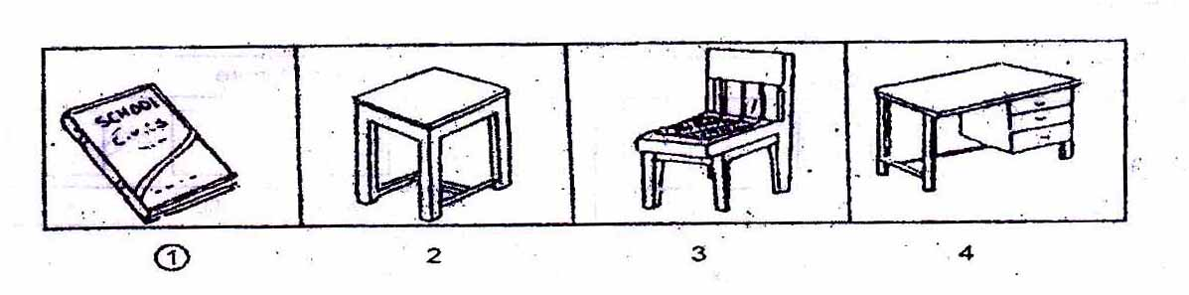

PART- II ( FIGURE MATCHING)

Directions:
In questions 6 to 10, a problem figure is given on the left side and four answer figures marked 1, 2, 3, 4 are given on the right side. Select the answer figure which is exactly the same as the problem figure.
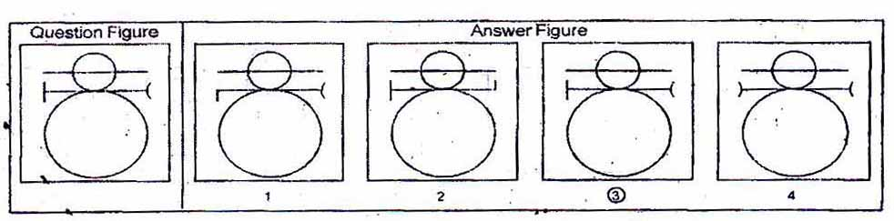

PART- III ( PATTERN COMPLETION)

Directions:
In questions 11 to 15 there is a problem figure on the left hand side, a part of which is missing. Observe the answer figures 1, 2, 3, 4 on the right hand side and find out the answer figure which without changing the direction, fits in the missing part of the problem figure in order to complete the pattern in the problem figure.
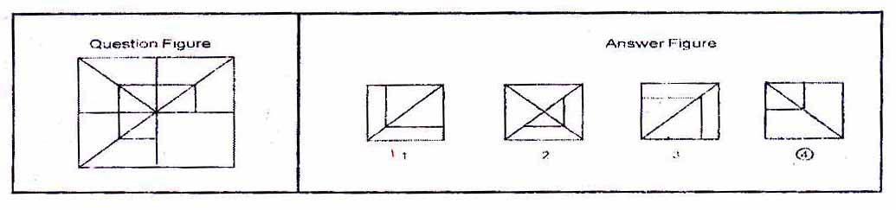

PART- IV ( FIGURE SERIES COMPLETION)

Directions:
In questions 16 to 20, there are three problem figures on the left hand side and the space for the fourth figure is left blank. The problem figures are in a series. Find out one figure from among the answer figures given on the right hand side, which occupies the blank space for the fourth figure on the left hand side and completes the series.
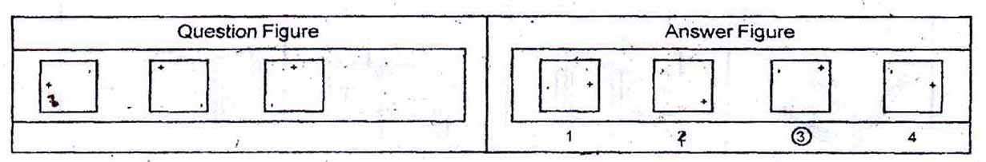

PART - V ( ANALOGY)

Directions:
In questions 21 to 25, there are two sets of two problem figures each. The second set has a mark of interrogation (?). There exists a relationship between the first two problem figures. Similar relationship should exist between the third and fourth problem figure. Select one of the answer figure which replaces the mark of interrogation.
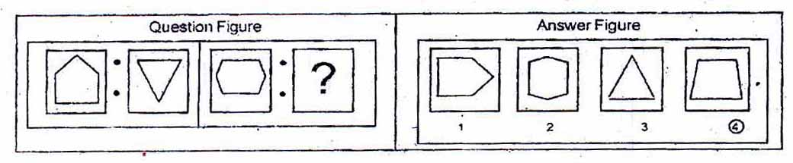

PART - VI { Geometrical Figure Completion (Triangle, Square, Circle) }

Directions:
In questions 26 to 30 one part of a square is on the left hand side as question figure and the other one is among the four answer figures 1, 2, 3, 4 given on the right hand side. Find out the figure that completes the square.
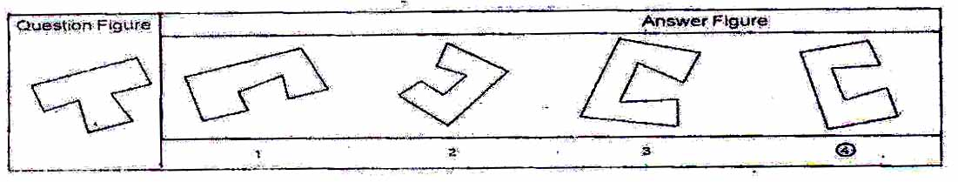

PART – VII (MIRROR IMAGING)

Directions:
In questions 31 to 35 there is a problem figure on the left side and four answer figures marked 1, 2, 3, 4 are given on the right side. Select the answer figure which is exactly the mirror image of the problem figure when the mirror is held at X Y.
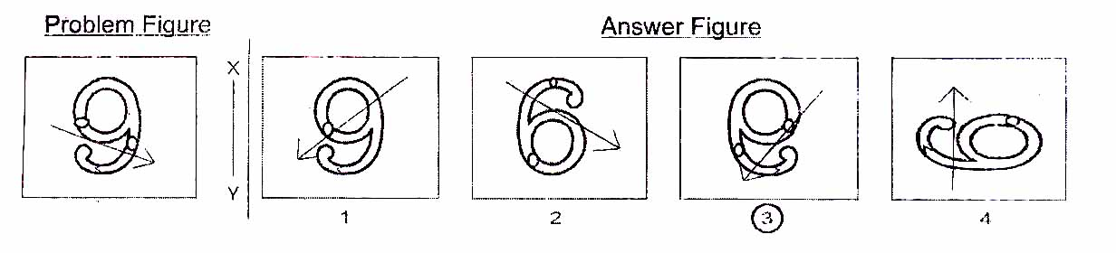

PART - VIII (PUNCHED HOLD PATTERN - Folding/Unfolding)

Directions:
In question 36 to 40 a piece of paper is folded and punched as shown in problem figures on the left side and four answer figures marked 1, 2, 3, 4 are given on right side. Select the answer figure which indicates how the paper will appear when opened (unfolded).
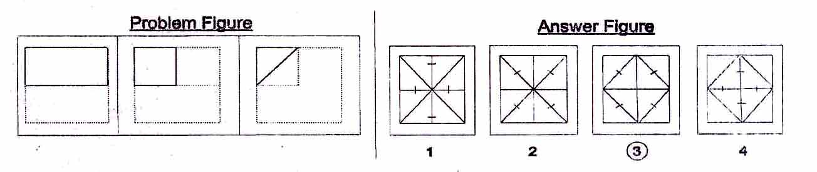

PART - IX (SPACE VISUALISATION)

Directions:
In questions 41 to 45 a problem figure is given on the left side and four answer figures, marked 1, 2, 3, 4 are given on the right side. Select the answer figure which can be formed from the cut-off pieces given in the problem figure.
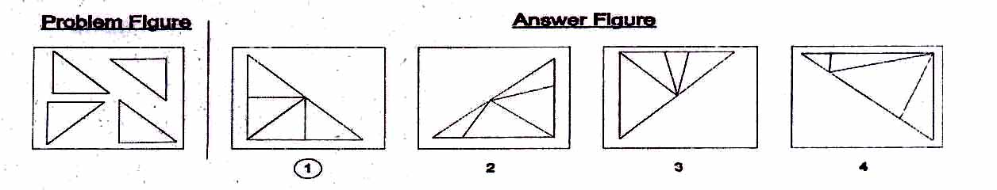

PART –X (EMBEDDED FIGURE)

Directions:
In questions 46 to 50 a problem figure is given on the left side and four answer figures, marked 1, 2, 3, 4 are given on the right side. Select the answer figure in which the problem figure is hidden/ embedded.

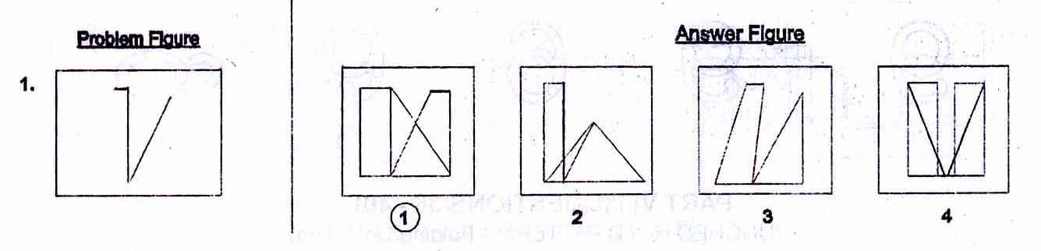

Section 2: Arithmetic Test

The main purpose of this test is to measure candidate's basic competencies in Arithmetic. All the Twenty-five questions of this test will be based on the following 15 topics

1. Number and numeric system.
2. Four fundamental operations on whole number.
3. Fractional number and four fundamental operations on them.
4. Factors and multiple including their properties.
5. LCM and HCF of numbers.
6. Decimals and fundamental operations on them.
7. Conversion of fractions to decimals and vice-versa.
8. Applications of number in measure length, mass, capacity, time, money etc
9. Distance, time and speed.
10. Approximation of expressions.
11. Simplification of Numerical Expressions,
12. Percentage and its applications.
13. Profit and loss.
14. Simple interest.
15. Perimeter, area and volume.

Note:- Emphasis will be more on testing of understanding and Application of the concepts and skills Involved. In order to provide some guidance to the candidates on the types of questions that are expected in Arithmetic lest, some examples are given below-

Example - 1 (Test of Understanding):

What is the prime factorization of 1000?
1. 10x10x10
2. 2x5x5x10
3. 2 x 2 x 2 x5 x 5
4. 2 x 2x 2 x 5 x5 x 5

A factorization of a number is said to be a prime factorization if (i) the product of the factors (taking a factor as many times as it occurs) is equal to the given number, and (ii) each factor is a prime number. Here only serial number 4 satisfies both the requirements. As such, serial number 4 is the correct answer.

Example 2 (Test of Understanding):

What is the average of first four odd numbers?
  - 2.5
  - 4
  - 5
  - 16
The first four odd numbers are 1.3.5 and 7. Their average (l+3+5+7)/4. As such, serial number 2 is the correct answer.

Example 3 (Test of Application):

A 1 km. long goods train is running at speed of I km. per 3 minutes, the time taken by this train to pass through 2 kms. Long tunnel is:

1. | 1 minute
2. | 3 minute
3. | 6 minute
4. | 9 minute

The tunnel is 2 km. long and the train is I km. in length, the train will have to cover a total distance of 3 km. in order to pass through the tunnel running at a speed of 1 km, per 3 minutes, the train will take 9 minutes to pass through ibis tunnel and that is the correct answer. As such, serial number 4 is the correct answer.

Section 3: Language Test.

The main purpose of this test is to assess reading comprehension of the candidates. The test consists of three passages. Each passage is followed by 5 questions. Candidates shall read each passage carefully and answer the questions that follow. In addition, there will be 10 questions to test grammar and writing skills of candidates.

Given below is a specimen passage and the questions that follow the passage.

PASSAGE

Forests are useful to us in many ways. They provide us with timber to build houses and make furniture. Forests also provide us with wood for fuel and making paper. They provide shelter for birds, wild animals and insects. Forests bring rainfall. Existence of forests is very important for the preservation of the ecosystem. The fact that we have to care for an ecosystem is indisputably established. Wise use of the environment and its resources are essential for man's continued survival.

1. To preserve the ecosystem, existence of...............is essential.
1. forests
2. animals
3. human beings
4. resources

2. Opposite of preservation' is...............
1. conservation
2. construction
3. shelter
4. destruction

3. Which one of the following is not a synonym of 'wise'?
1. Sensible
2. Intelligent
3. Humorous
4. Judicious

4. Carpenters depend on forests because they provide...............
1. wood for fuel
2. wood for making paper
3. timber to make furniture
4. houses for animals

5. Wild animals will become homeless if...............
1. paper mills are destroyed
2. houses are built
3. forests are destroyed
4. ecosystem is taken care of

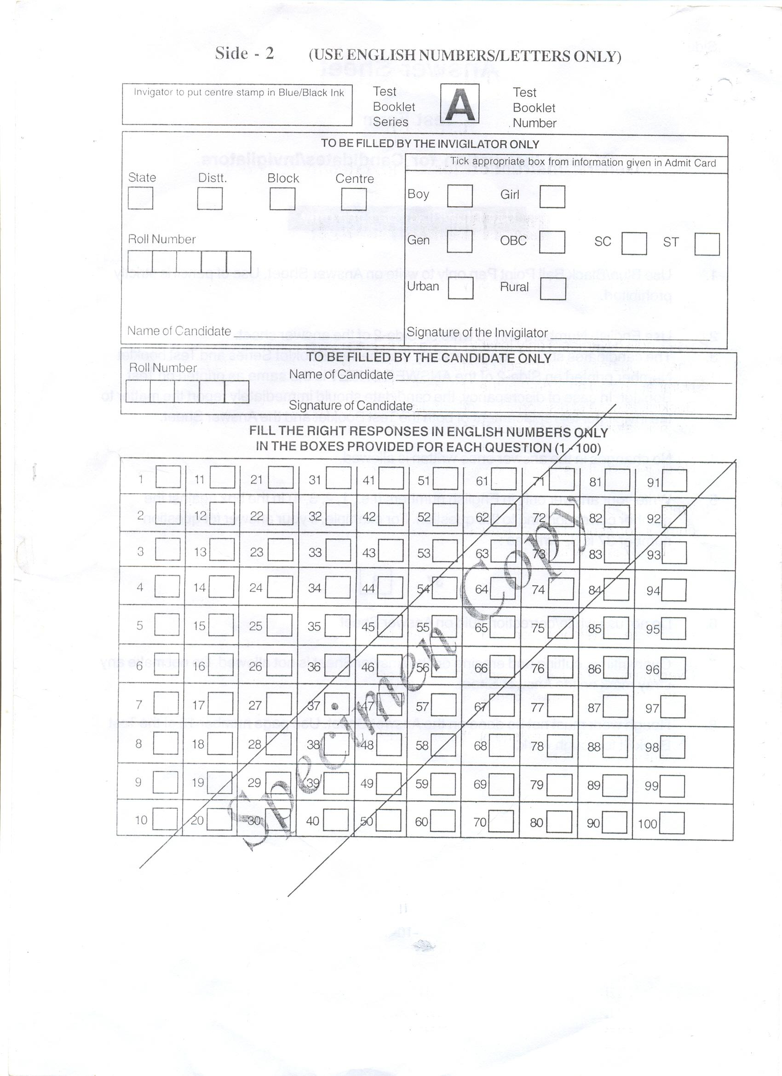
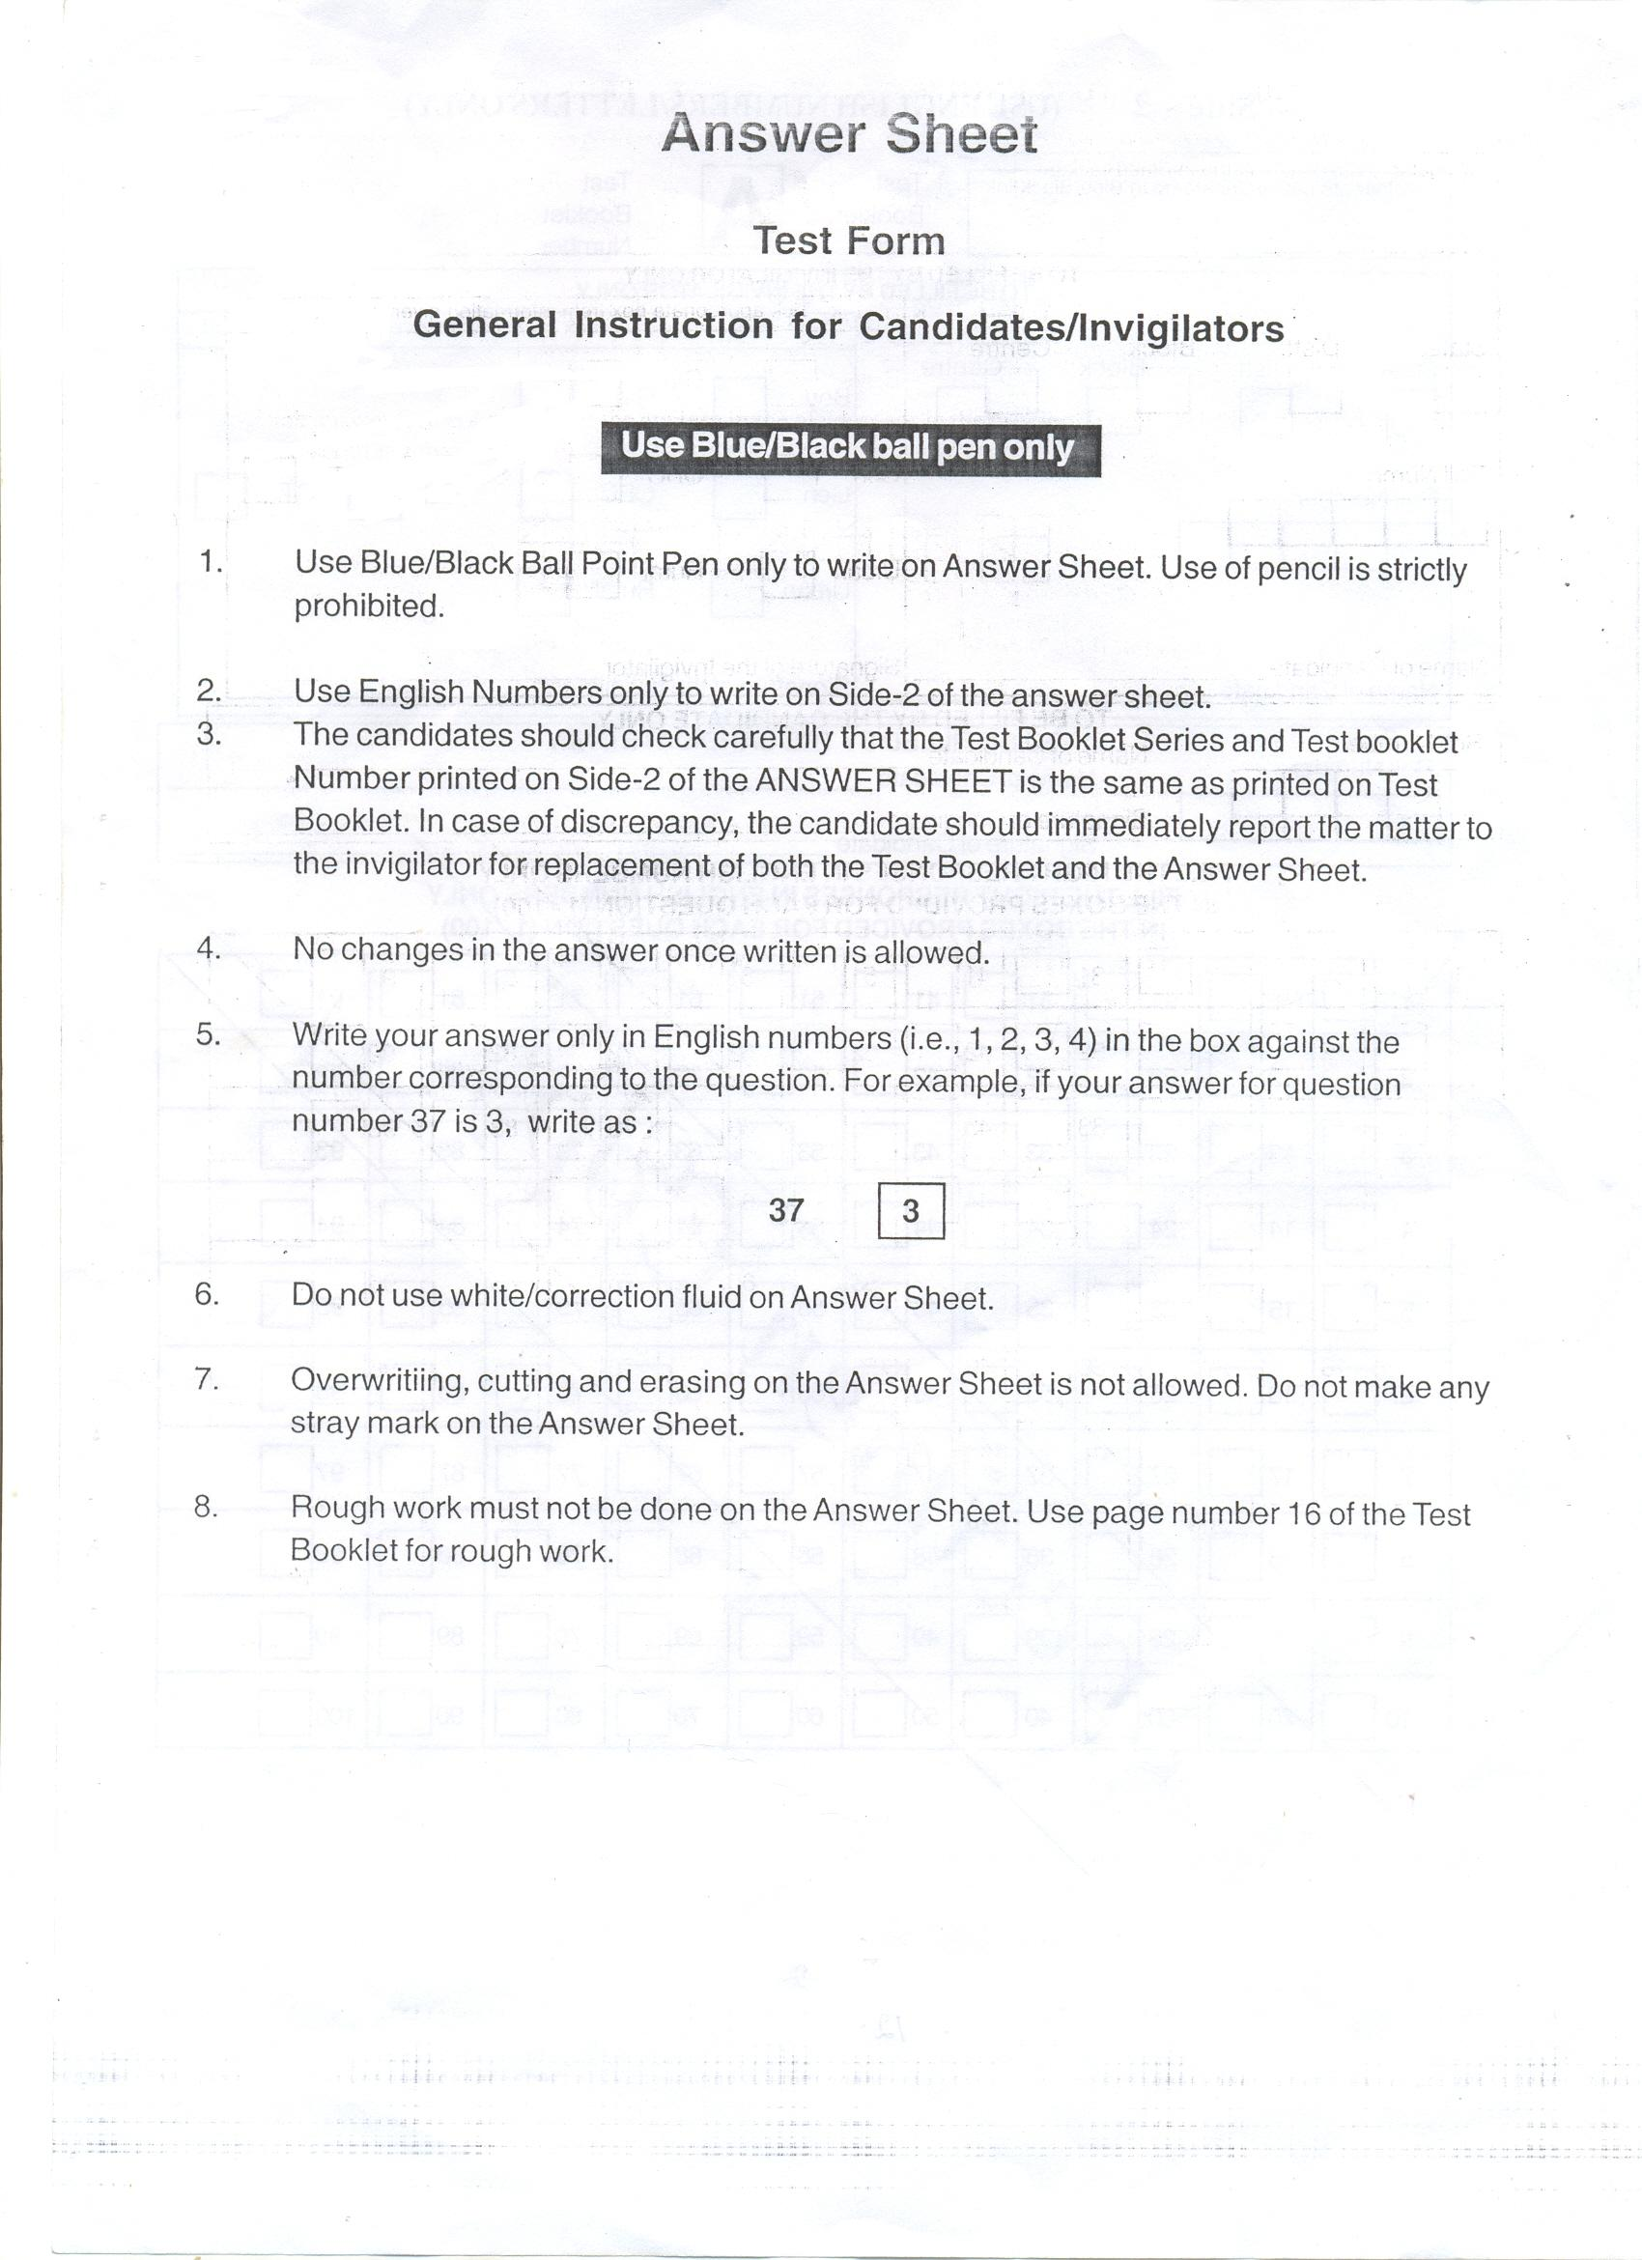
JAWAHAR NAVODAYA VIDYALAYA SELECTION TEST 2014
APPLICATION FORM
(Last date of submission of application form in office of Block Education Officer is 31st October 2013)
Roll No. ( To be filled in by the Office of Principal, JNV)
Note : | Before filling read carefully the instructions for each column provided along with this application form (see page 4). The form is to be filled in neatly and legibly. Application incomplete or vague in any respect will be summarily rejected. |  |  |  |  |  | Affix Passport size photograph  Photograph to be attested by the Head of the school where the candidate is studying in Class-V.
1. |  | Name of the Candidate (IN BLOCK LETTERS)  First Name Middle Name Surname  Master/Km.___________________________________________________________________________________________
2 |  | Tick ( ) the Appropriate Box  Boy Girl Gen SC ST OBC Rural Urban  a. Sex b. Category c. Area  d. Disabled: Physically Handicapped Visually Impaired Hearing Impaired
3. |  | Date of Birth : D D M M Year  In figure  In words ________________________________________________________________________________
4. |  | Identification Mark : ________________________________________________________________________________________
5. |  | a. Mother’s Name (BLOCK LETTERS) : ___________________________________________________________________________  b. Father’s Name (BLOCK LETTERS) : ___________________________________________________________________________  c. Name of the Guardian (In case Father / Mother is not the Guardian)______________________________________________________  d. Relationship with Candidate : ___________________________________________________________________________  e. Annual Income of Parents : Rs _______________ (in words) Rupees __________________________________
6. |  | a. Present Postal Address _________________________________________________________________________________________  _____________________________________________________________PIN Code_______________________________________  b. Permanent Address ___________________________________________________________________________________________  _____________________________________________________________PIN Code ______________________________________  c. Telephone No. with STD code ____________________________________E-Mail ID ______________________________________
7. |  | Nationality: __________________________________________________ 8. Religion ______________________________________
9. |  | School (s) from where the candidate passed Classes-III, IV and is studying in Class-V
 |  |  | Classes | Class-III | Class-IV | Class-V
a) |  | (I) | Name of the School
 |  | (II) | Category of School (Recognized/Not Recognized)
b) |  | (I) | Month and Year of Joining
 |  | (II) | Month of Passing Class
c) |  | (I) | Name of the Village or Town  (in which the School is located)
d) |  |  | Name of the Block
e) |  |  | Name of the District
f) |  |  | *School Location : Rural / Urban
10. | Language / Medium of Examination : Please indicate any one language out of the 21 Languages given in the Prospectus ‘About the Selection Test’ at Point No.2 (Language of the Examination) ____________________________________________________________
* | A candidate will be belonging to the Rural Category, if
(a) | She/he had been studying for all the three academic sessions of Classes-3rd, 4th and 5th each year from the schools located in rural areas of the district. If the candidate has studied for even a single day in Urban School, she/he will be treated as Urban.
(b) | She/he had studied from Accredited Centres/Institutions of Serva Shiksha Abhiyan/National Institute of Open Schooling and She/he has been residing in a rural area away from the centres in case centres are in Urban area.

UNDERTAKING BY THE APPLICANT/GUARDIAN

I, hereby declare that the particulars given above are true to the best of my knowledge and belief. I am aware that, even if selected in JNVST, the applicant is eligible for admission to Jawahar Navodaya Vidyalaya, only if the relevant documents in proof of the particulars mentioned above are produced at the time of admission. I also understand that for promotion of National Integration and as per the scheme of the Jawahar Navodaya Vidyalayas, students from one JNV have to migrate to another JNV (from Hindi Speaking area to non-Hindi speaking area and vice versa) and I agree to abide by the rules of the Navodaya Vidyalaya Samiti in this regard.

Signature of Candidate ____________________ Signature of Father / Mother / Guardian ____________________

Name of Candidate ________________________ Name of Father / Mother / Guardian _______________________

Place : ______________

Date : ______________

CERTIFIED BY HEAD OF SCHOOL WHERE APPLICANT IS STUDYING

Certified that the particulars given in this application of Master/Kumari ___________________________________, son/daughter of Mr./Mrs.____________________________ are found correct as per the school records.

Headmaster’s Signature __________________________ BEO’s Signature __________________

Office Stamp Office Stamp

Place : ______________ Place : ______________

Date : ______________ Date : ______________

FOR USE OF NAVODAYA VIDYALAYA OFFICE

State District Block Centre

Scrutinized by____________________________ ________________________________
(Signature & Name of the JNV Official) Signature of Principal, JNV

Place : ____________________
Date : _____________________ Office Stamp
JAWAHAR NAVODAYA VIDYALAYA SELECTION TEST- 2014

ADMIT CARD
Date & Time of Test : _____________________

Affix Passport size photograph
Photograph to be attested by the Head of the school where the candidate is studying in Class-V

(A) (FOR OFFICE USE)

Code

Name …………… …………… ………….. ………….. …………………………………..
State District Block Centre Roll No.
Name of Examination Centre …………………………………………………………..………………………………………
Following is to be filled in by the candidate in CAPITAL LETTERS
(To be signed by Head Master of the School)

1. Medium of Examination Centre (It shall be the same as the medium of instruction as given in column 10 of Application Form)

2. Name of the Candidate : Master / Kumari ……………………………………………………………………………………………………………………………………………………………

3. a. Mother’s Name (Block Letters) : .………………………………………………………………………………………………………………………………………………………………….

b. Father’s Name (Block Letters) : …………………………………………………………………………………………………………………………………………………………………….

c. Name of the Guardian : ……………………………………………………………………………………………………..…………………........................................................
(In case father/mother is not guardian)

d. Relationship with candidate: .……………………………………………………………………………………………………………………………………………………………………...

4. a. Present Postal Address : …………………………………………………………………….…. PIN code ……………….................................

b. Permanent Address : …………………………………………………………………….…. PIN code ……………….................................

c. Contact Phone No. with STD code ______________________________________________

5. Date of birth : D D M M Y E A R
(In figures)

(In words) …………………………………………………………………………………………………………………………..

6. Tick ( ) the Appropriate Box
Boy Girl Gen SC ST OBC Rural Urban
a. Sex b. Category c.

7. Disabled: Physically Handicapped Visually Impaired Hearing Impaired

8. Name of the School where candidate is studying in Class V-----------------------------------------------------------Village---------------------------------Tehsil--------------------------------------------District--------------------------------Tel. No.----------------------------------------------------
_____________________________________  Signature of the candidate in the presence of HM/Head of Accredited Institute or Centre of the School where candidate is studying |  | ______________________________________  Signature of the Headmaster/Head of Accredited Institute or Centre of the School attesting the photograph with official stamp.
___________________________________________
Signature of the Principal, JNV allotting the Roll No.
With Official Stamp
Parents are requested to collect the acknowledgement/Receipt after depositing the application form. This acknowledgement will have to be produced while receiving the Admit Card from the Block Education Officer concerned. In case, Admit Card is not received before one week of the date of Selection Test, contact the Principal JNV / BEO / DEO concerned immediately.
ACKNOWLEDGEMENT
Received the application form from Master/Kumari……………………………………………………son/daughter of …………………………….
for admission in Jawahar Navodaya Vidyalaya through Jawahar Navodaya Vidyalaya Selection Test 2014.
…………………………………………..
Signature of the Block Education Officer
Date : ………………… With official Seal

SOME IMPORTANT GUIDELINES FOR FILLING THE APPLICATION FORM
The Application form for admission to Class VI in Jawahar Navodaya Vidyalaya is self-explanatory. However, following guidelines may be specifically kept in view by the students and their parents/guardians.

- Please read the Prospectus and the Application Form carefully. Fill in complete information after ensuring that the candidate fulfills all the prescribed requirements such as date of birth within prescribed range (1.5.2001 to 30.4.2005) schooling in classes III, IV & V in recognized institution(s). (Govt. / Govt. Aided / Recognized / Accredited Institute / Centres of Sarva Shiksha Abhiyan / NIOS).

- Carefully put tick mark () in appropriate box with regard to category i.e. General, SC, ST, OBC & Disabled. In case at the time of admission, it is found that a candidate has ticked SC/ST box though he/she does not actually belong to SC/ST community, his/her selection is liable to be cancelled. Mention at 2(b) the caste if the candidate belongs to Schedule Caste (SC) or Schedule Tribe (ST). Mention at 2 (d) the specific category if the candidate is disabled.

3(a) Mention at Sl.No. 3, the date of birth in figures as well as in words. Write correct Date of Birth as per school records. In case, it is observed at a later stage that the Date of Birth of the candidate does not match with the school records the candidature is liable to be rejected.

(b) Appropriate permanent identification marks which can be identified clearly shall be mentioned in Column No.4 of the Application Form by the candidate.

4. Affix two recent passport size photograph (one on the Application Form and the other on the Admit Card). The photographs should be attested by the Head Master of School / Accredited Institute / centre where the candidate is studying in class V. The impression of the signature and the official stamp should be such that it overlaps, impart with photograph.

5. Both the candidate and the father / guardian should sign the Application Form (with date) after studying the terms and conditions etc. given in the Prospectus and Application Form.

6. Take the help of the Head of the School, if needed, while filling the Application Form. Get the Application Form signed and stamped by the Head of School before submission to the Block Education Officer (BEO).

7. The candidate should fill up Column No. 1 to 7 of the Admit Card and should sign the Admit Card in the presence of the Head of the Institution where he/she is studying at the time of the submission of the Application Form.

8. The last date of submission of Application Form in the office of the Block Education Officer (BEO) is 31stOctober 2013 for test to be conducted on 8th February, 2014 (Summer Bound JNVs) as well as test to be conducted on 12th April,2014 (Winter Bound JNVs) & 7th June, 2014 (Extreme Winter Bound JNVs.

CAUTION : Application Form is liable to rejection if columns are left blank or the entries are incomplete. Applicants should ensure that they fulfill all the prescribed requirements of education, age and of special categories (like SC/ST/Disabled) area (Urban/Rural) wherever applicable. If any information given in the original application form is found to be false / incorrect on subsequent verification, even after the selection of the candidate, the admission is liable to cancellation and the decision of Navodaya Vidyalaya Samiti will be final and binding. No correspondence shall be entertained in this regard. Such admissions, if any obtained by any candidate on the basis of false certificate / declaration / information shall not only be cancelled but Samiti also reserves the right to recover the expenditure incurred on a student during his/her entire stay in a Vidyalaya.
Affidavit

(An affidavit to be furnished by parents on `_____Stamp paper duly attested by
Notary at the time of admission to Class VI in JNVs through JNVST)

I ___________________________________ Aged____________Years, Father/Mother of Master/Kumari____________________________ Resident of Village _________________________________ Post Office ______________________________________ Tehsil ___________________________________ District_____________________ solemnly declare and affirm as under :

- My ward is a student of ______________________________(name and complete address of the Institution) located in ____________________________, which is a rural area in District in State since __________________________________.

He/She has passed Class–V from this Institution during the session _________________.

- My ward is residing with me at following address which is located in the ___________rural/urban area of District________________.

Verified on this _______________day of ___________________2014 at _______________place that the contents of above affidavit are true to best of my knowledge and belief based on record and believed by me to be true.

Signature

Name

Place_________________
Date_________________
RESIDENCE CERTIFICATE

(To be furnished by the parents of the qualified children at the times of admission to JNVs)

As per Jawahar Navodaya Vidyalaya __________________________________________________
District _________________ State _______________________ Letter no. ________________________
Dated _____________ my ward Mast./Kum _______________________________________has qualified
the entrance exam for admission to Class VI at JNV ____________________ District ______________________
State / UT _______________________ during the session _____________________.

I am residing along with my ward mentioned above the following address since _____________________

Village ______________________________
Town _______________________________
District ______________________________
State _______________________________
Pin Code ____________________________

Certified that the information furnished by me is true and no fact has been concealed.

Signature of Parents
Full Name
Address

Place __________________
Date ___________________

CERTIFICATE

(To be filled by the District Authorities and issued under the signature of SDM/ Tehsildar to the parents of the child selected for admission to Class VI in JNVs through JNVST)

This is to certify that the above information furnished by Shri/Smt.___________________________________
Father/Mother of Master/Kumari__________________________________________a candidate selected for admission
to Class VI in JNV ____________________________ District ______________________________________ has been verified from the records and is found to be correct. The area where residence is located falls under (Rural/Urban) area of District ___________________.

Signature
SDM/Tehsildar

